Ta Quang Tung – 104222196

COS20019 – Cloud Computing Architecture - Wk8: ACA Module 10 Guided Lab - Automating Infrastructure Deployment with AWS CloudFormation

**Task 1 - Deploying a networking layer**

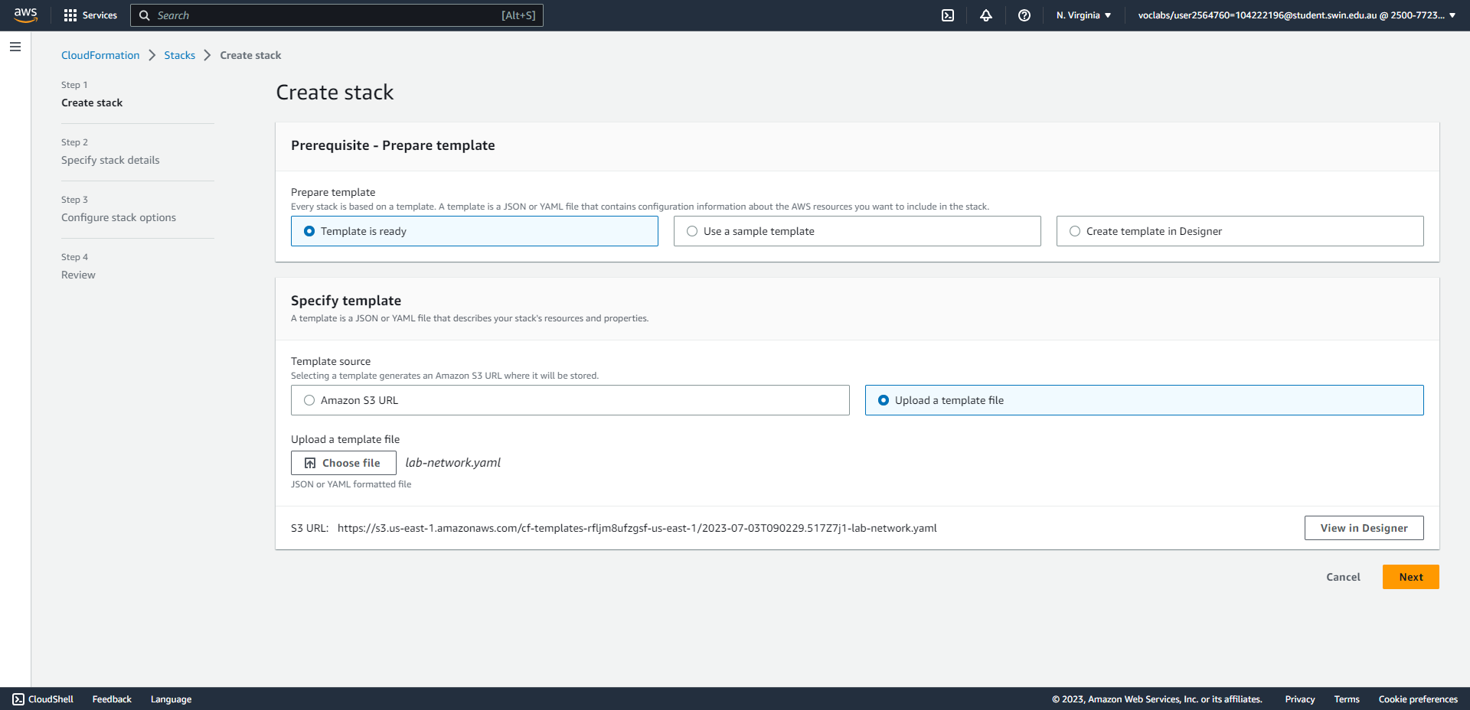

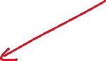

Steps 5-8: Create a network stack (choose the lab-network.yaml template)

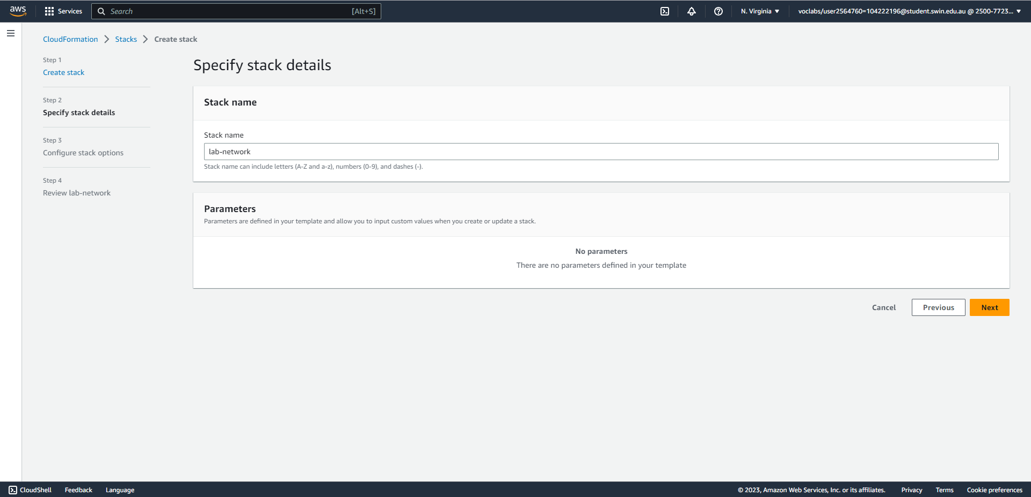



Step 8: Create a network stack (set the name to lab-network)

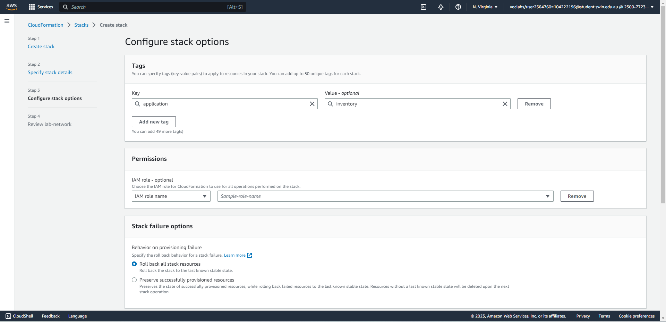

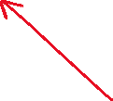

Step 8: Create a network stack (create a tag)

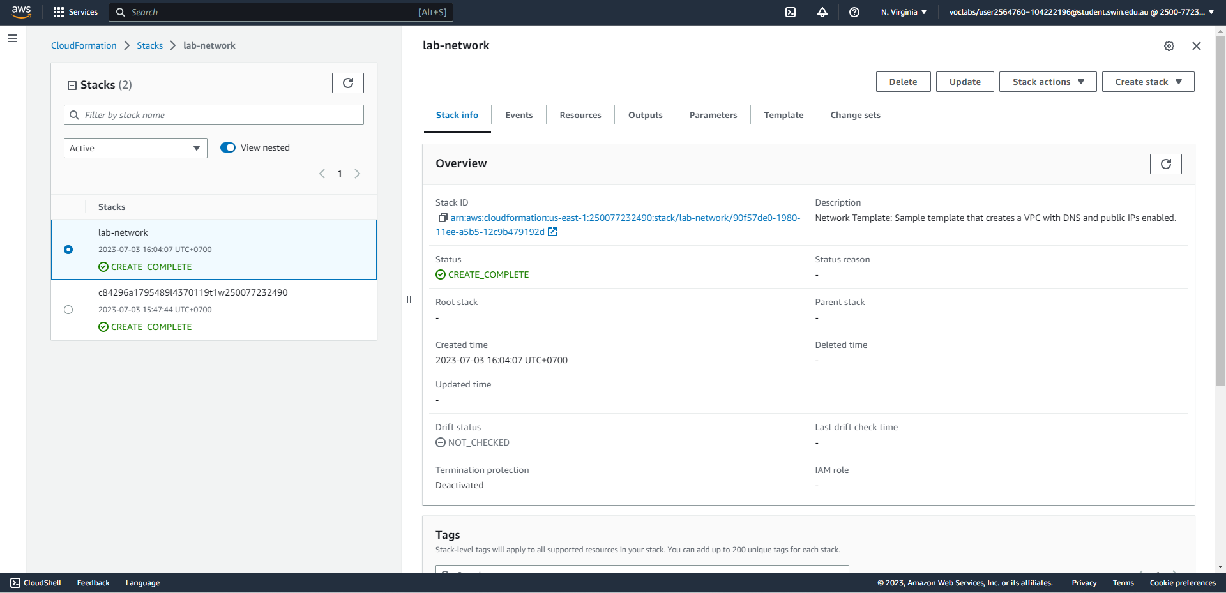



Steps 9-10: Wait for the status to become CREATE_COMPLETE.

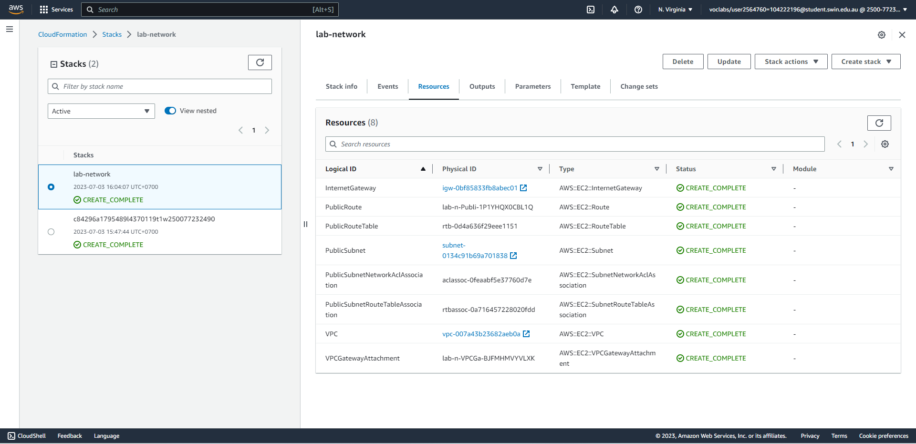



Step 11: The Resources tab of lab-network.

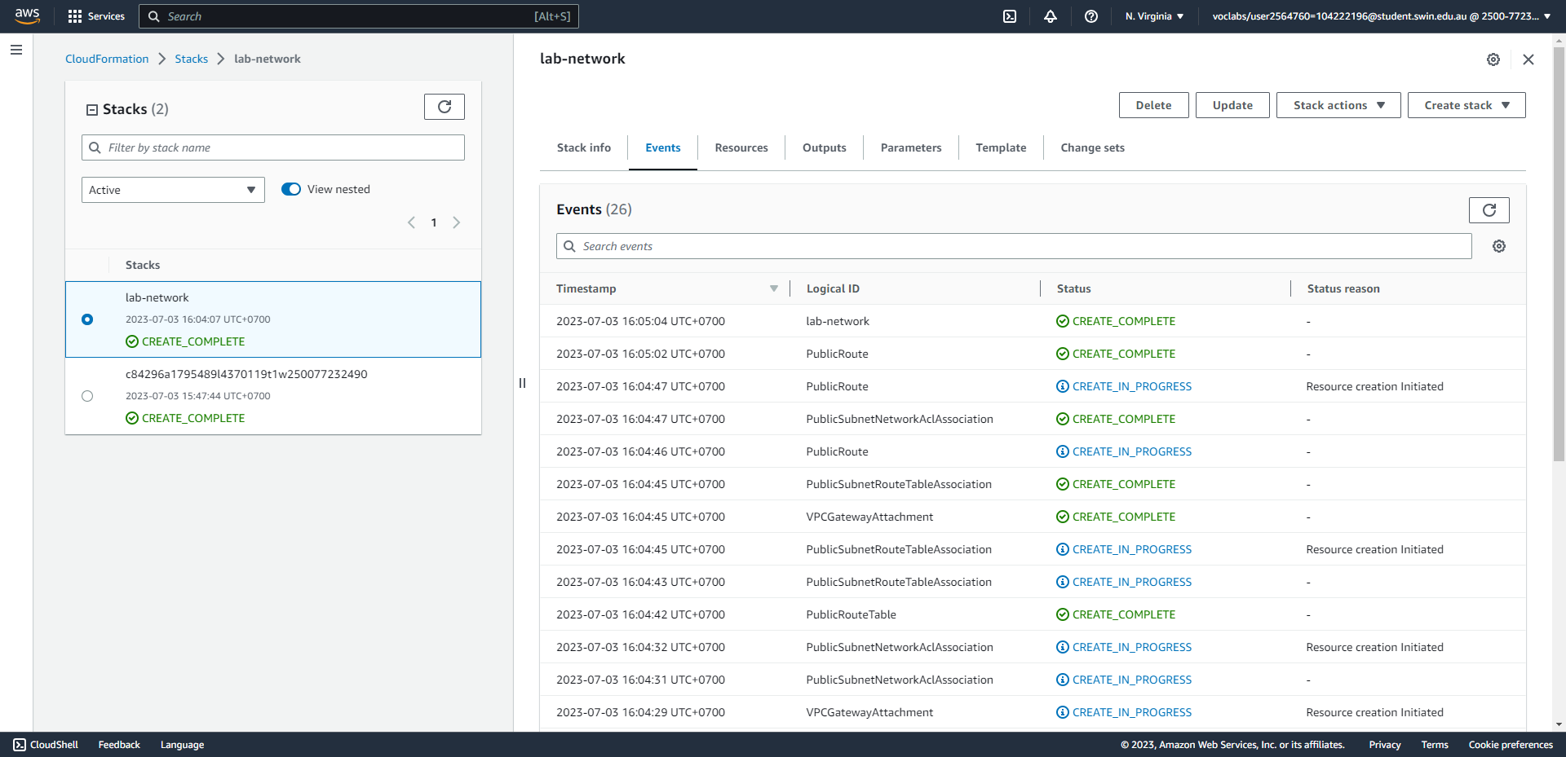



Step 12: The Events tab of lab-network.

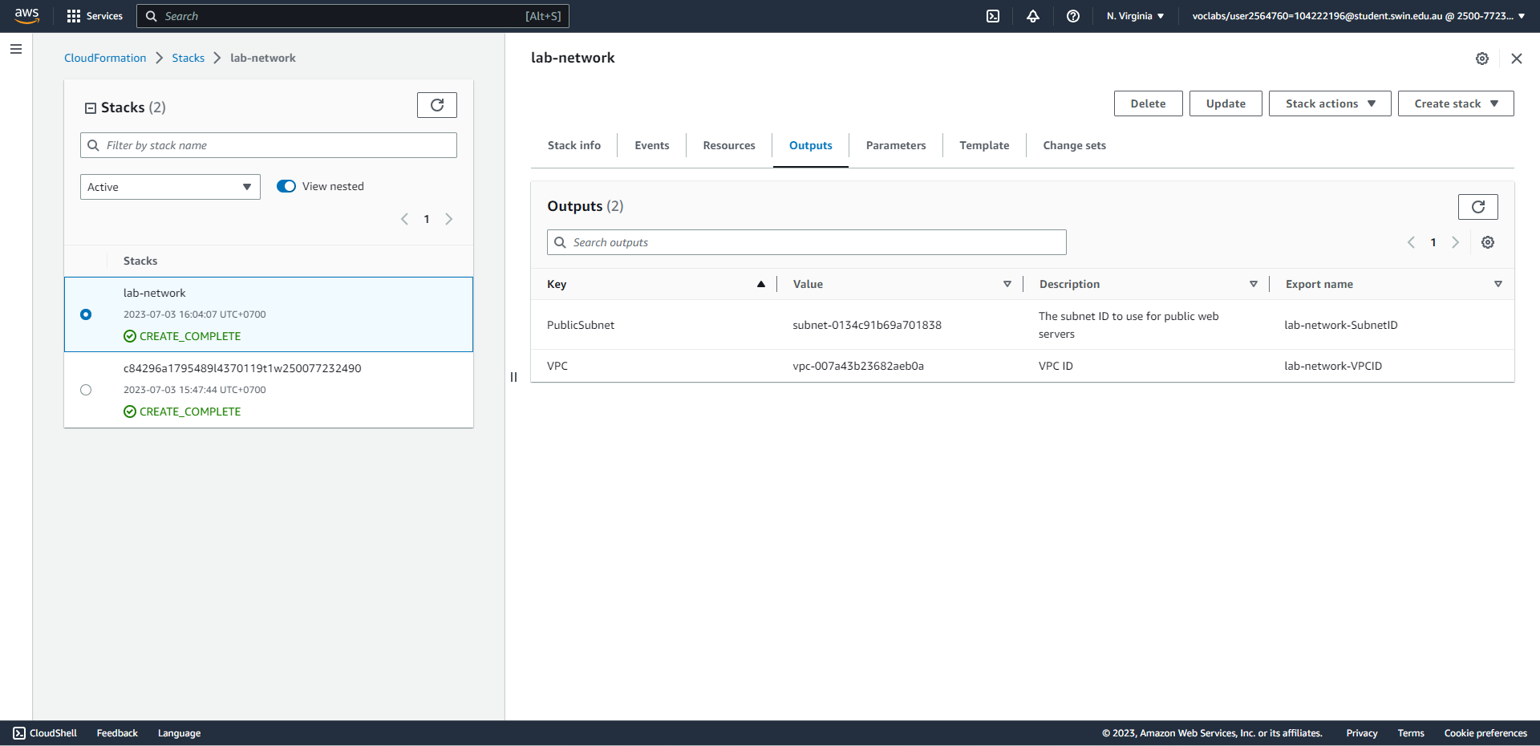



Step 13: The Outputs tab of lab-network. Two items are correctly shown.

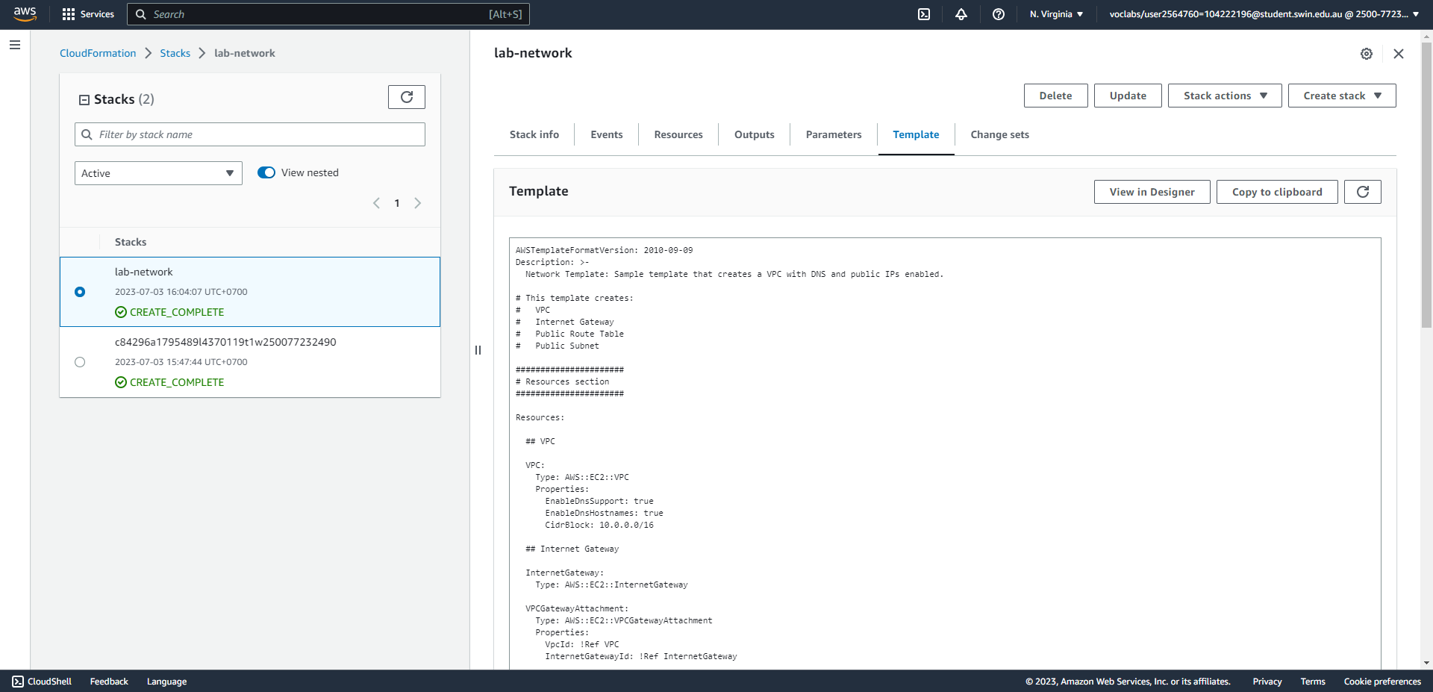



Step 14: The Template tab of lab-network.

**Task 2 - Deploying an application layer**

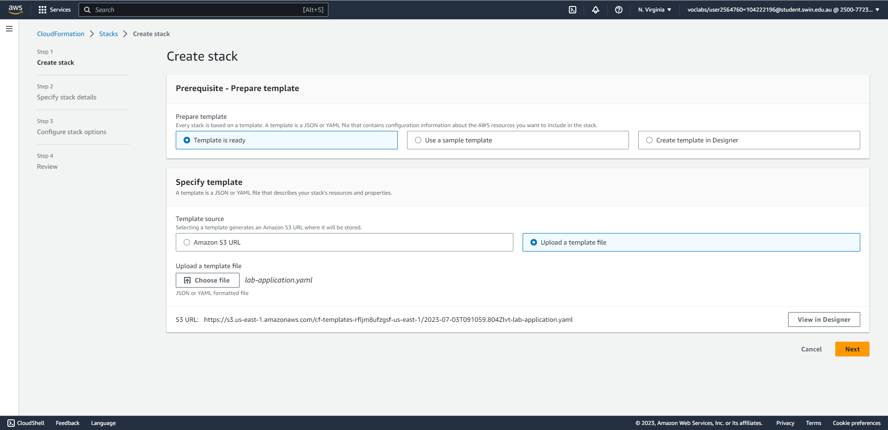

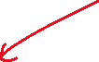

Steps 15-17: Create an application stack (choose the lab-application.yaml template.)

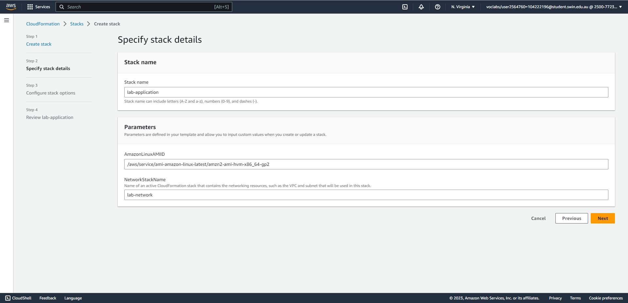

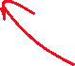

Step 17: Create an application stack (set the name to lab-application and set the network stack name to lab-network).

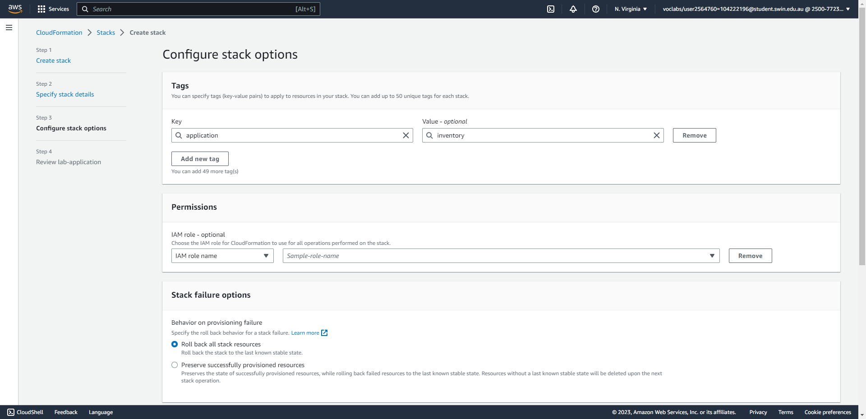



Step 17: Create an application stack (create a tag).

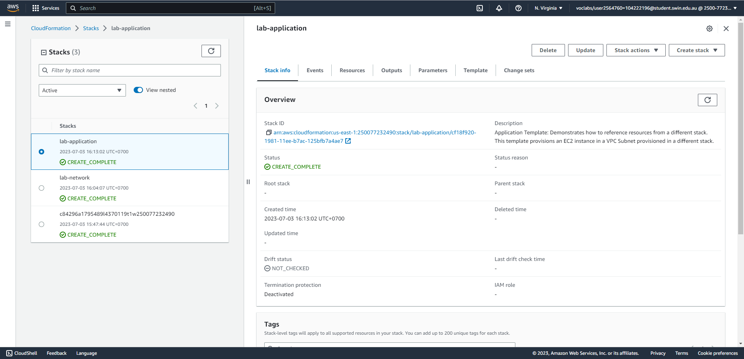



Step 18: Wait for the application stack to finish creating.

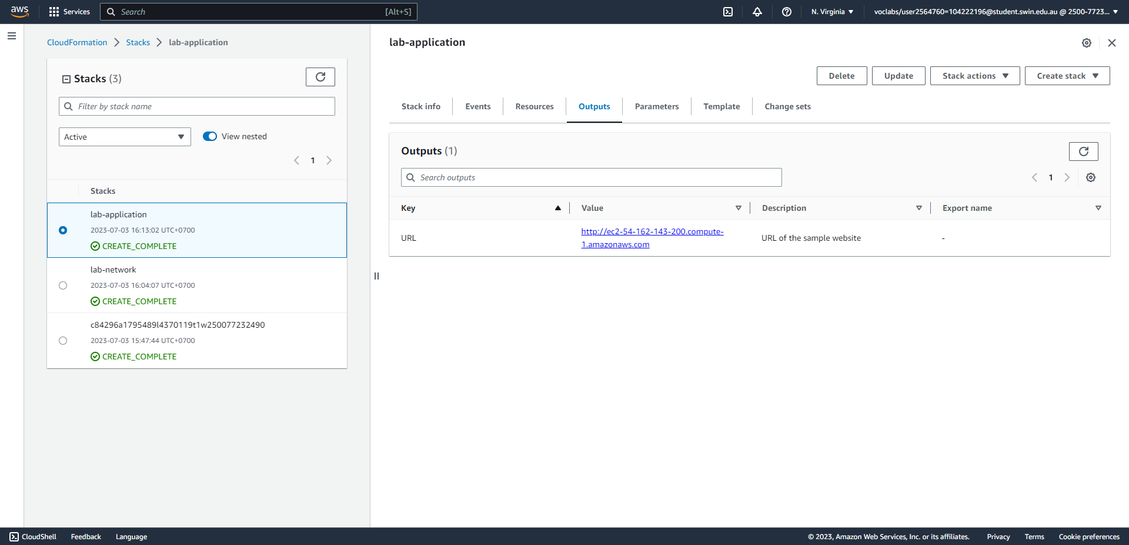



Step 19: In the Outputs tab of lab-application, copy the URL.

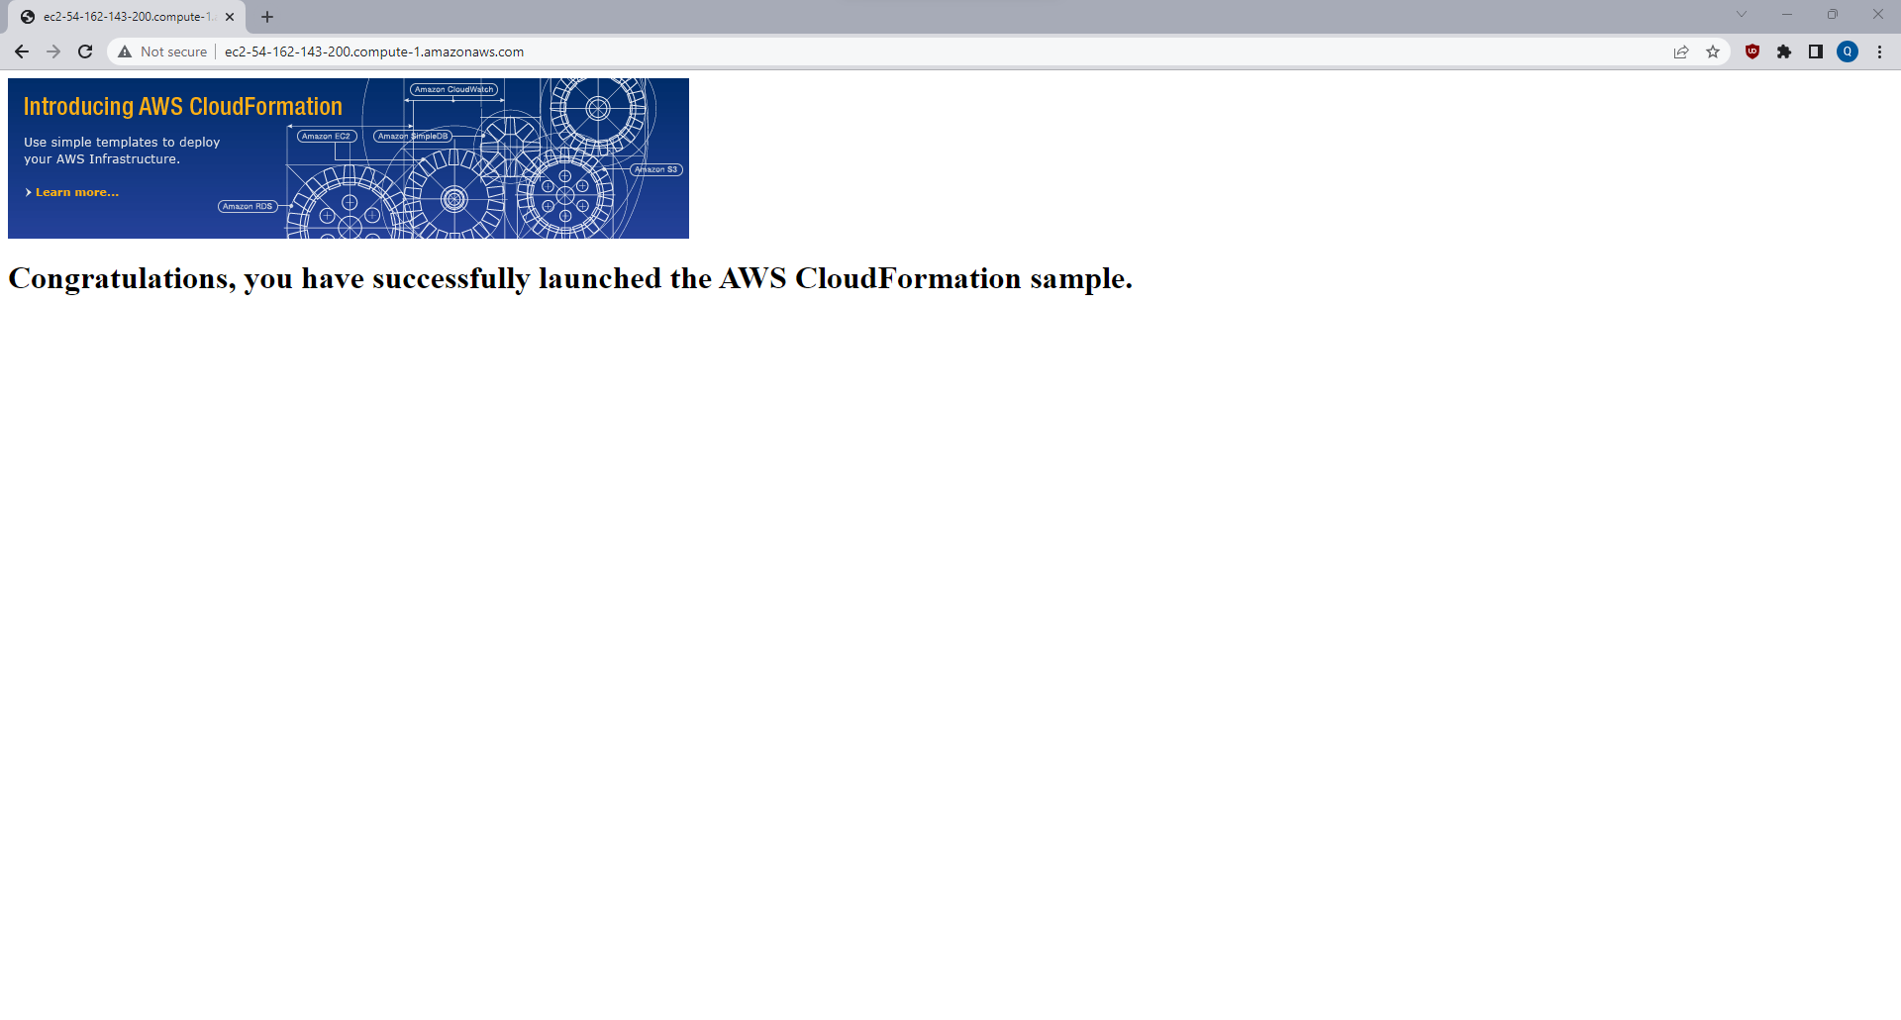

Step 20: Opening the URL in a new browser window, a webpage is shown.

**Task 3 - Updating a Stack**

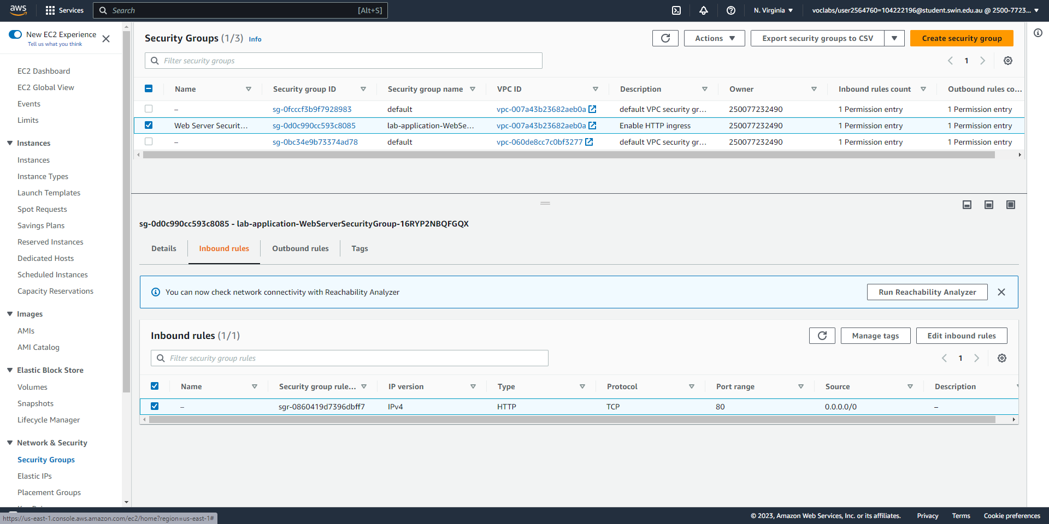

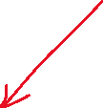

Steps 21-24: The Web Server Security Group shows one inbound rule that allows all inbound HTTP traffic.

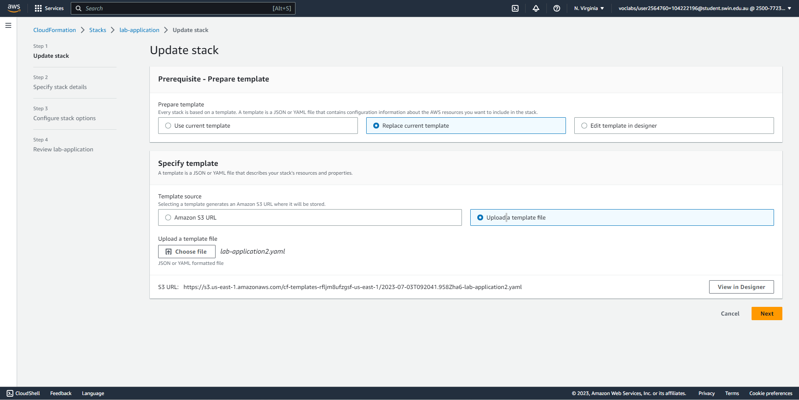



Steps 25-28: Update the application stack by specifying a new template file.

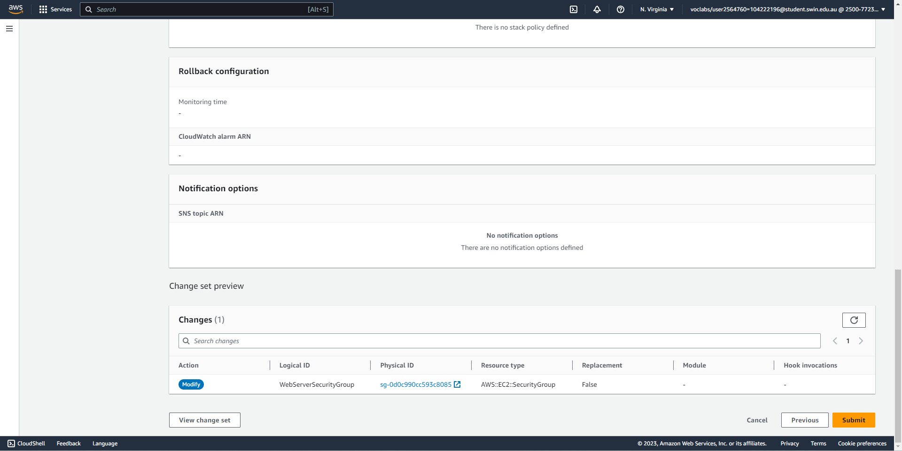



Step 29: CloudFormation shows the changes that will be applied, which in this case is only the Web Server Security Group.

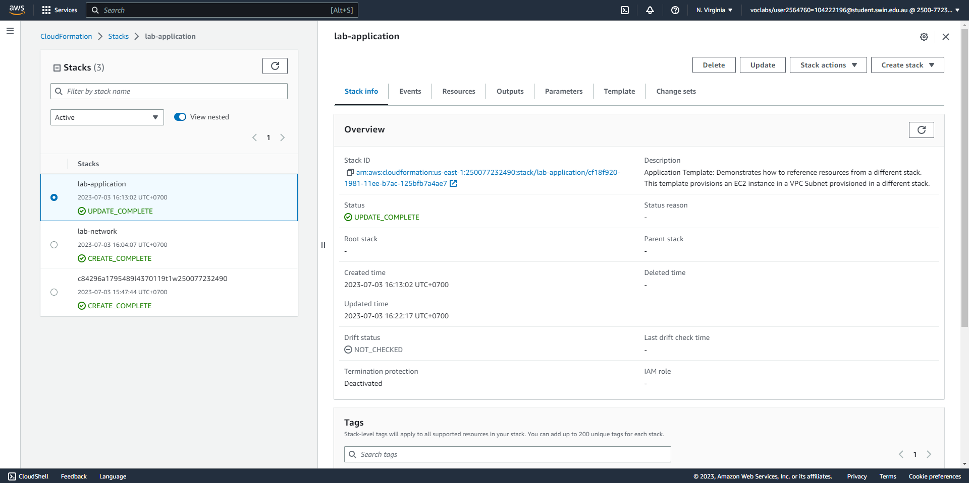



Steps 30-31: Wait for the update to complete.

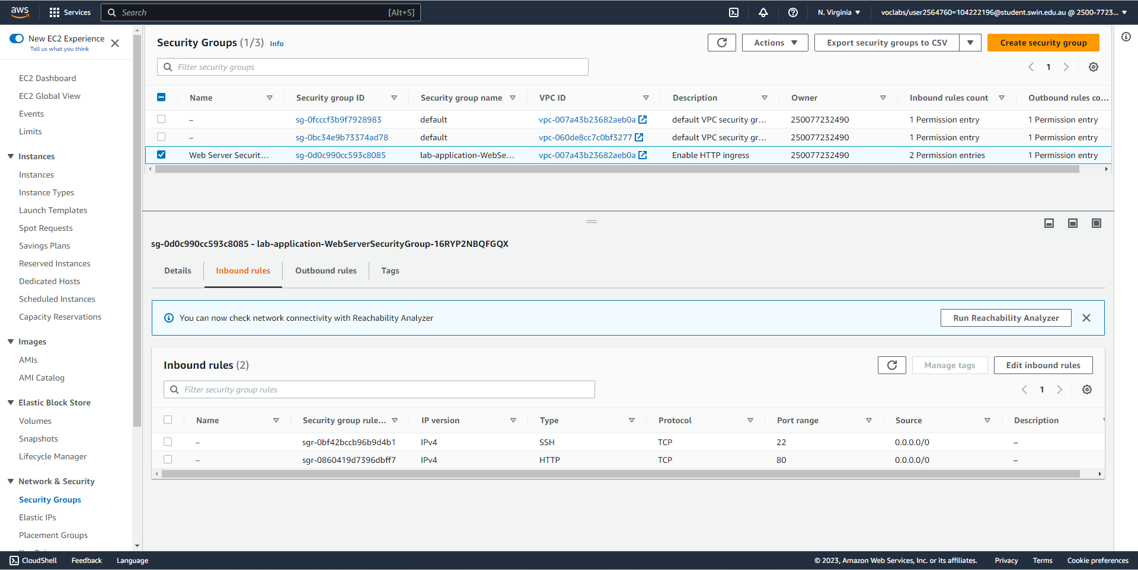



Steps 32-33: A new rule appears in the Web Server Security Group thanks to the new update.

**Task 4 - Exploring templates with AWS CloudFormation Designer**

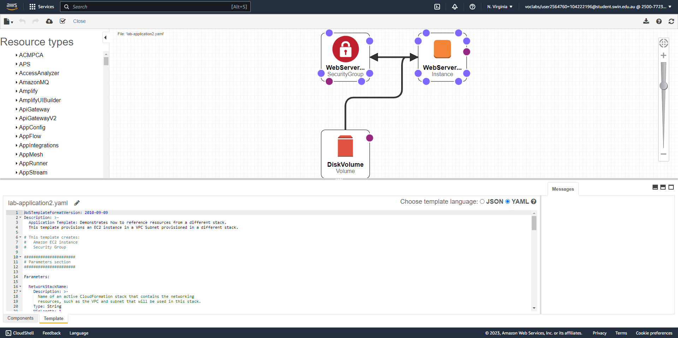

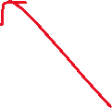

Steps 34-37: Uploading lab-application2.yaml to the designer results in the above diagram.

**Task 5 - Deleting the stack**

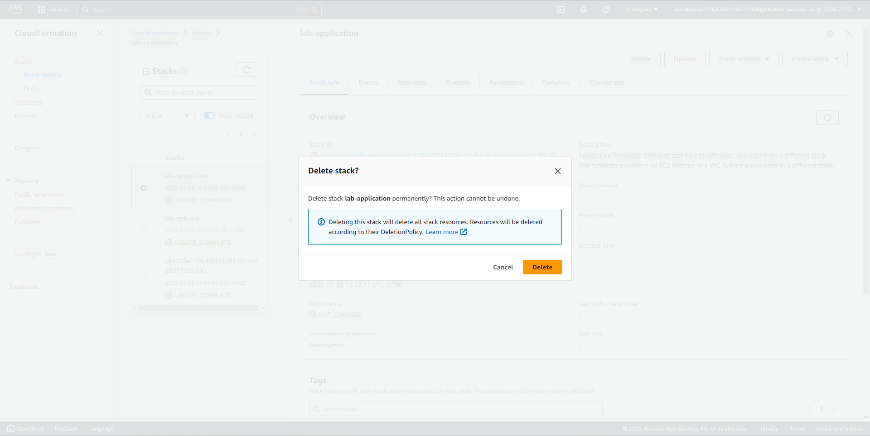



Steps 38-41: Delete the application stack.

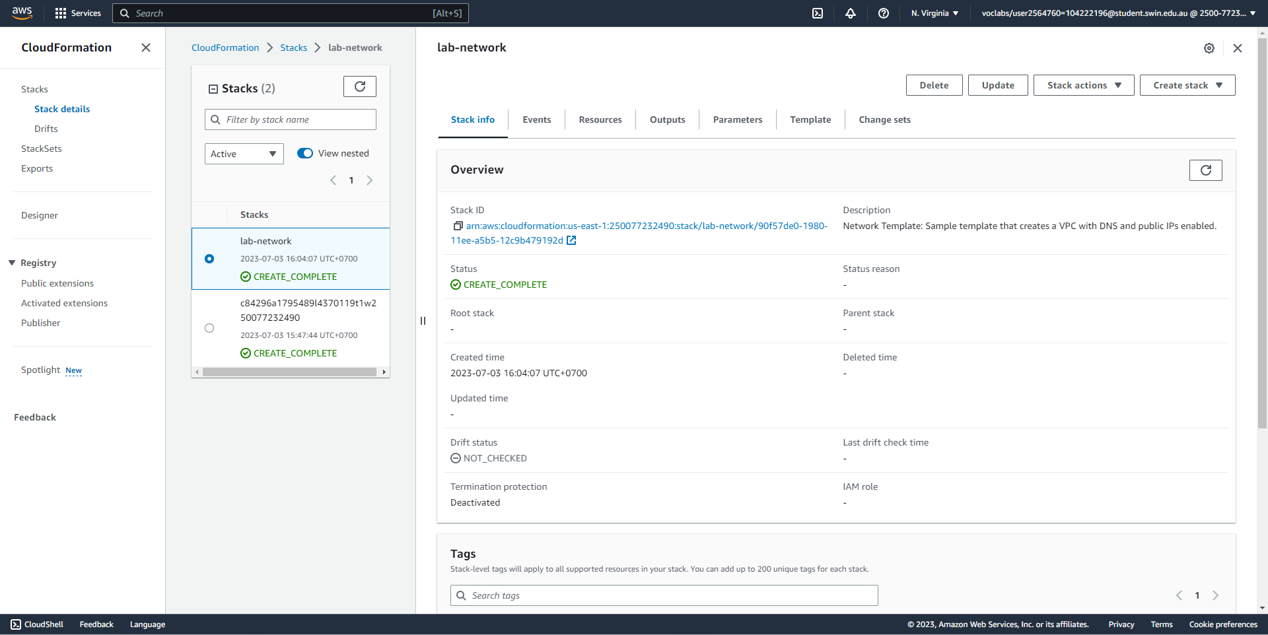

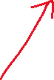

Step 42: The stack has been deleted and no longer appears in the list.

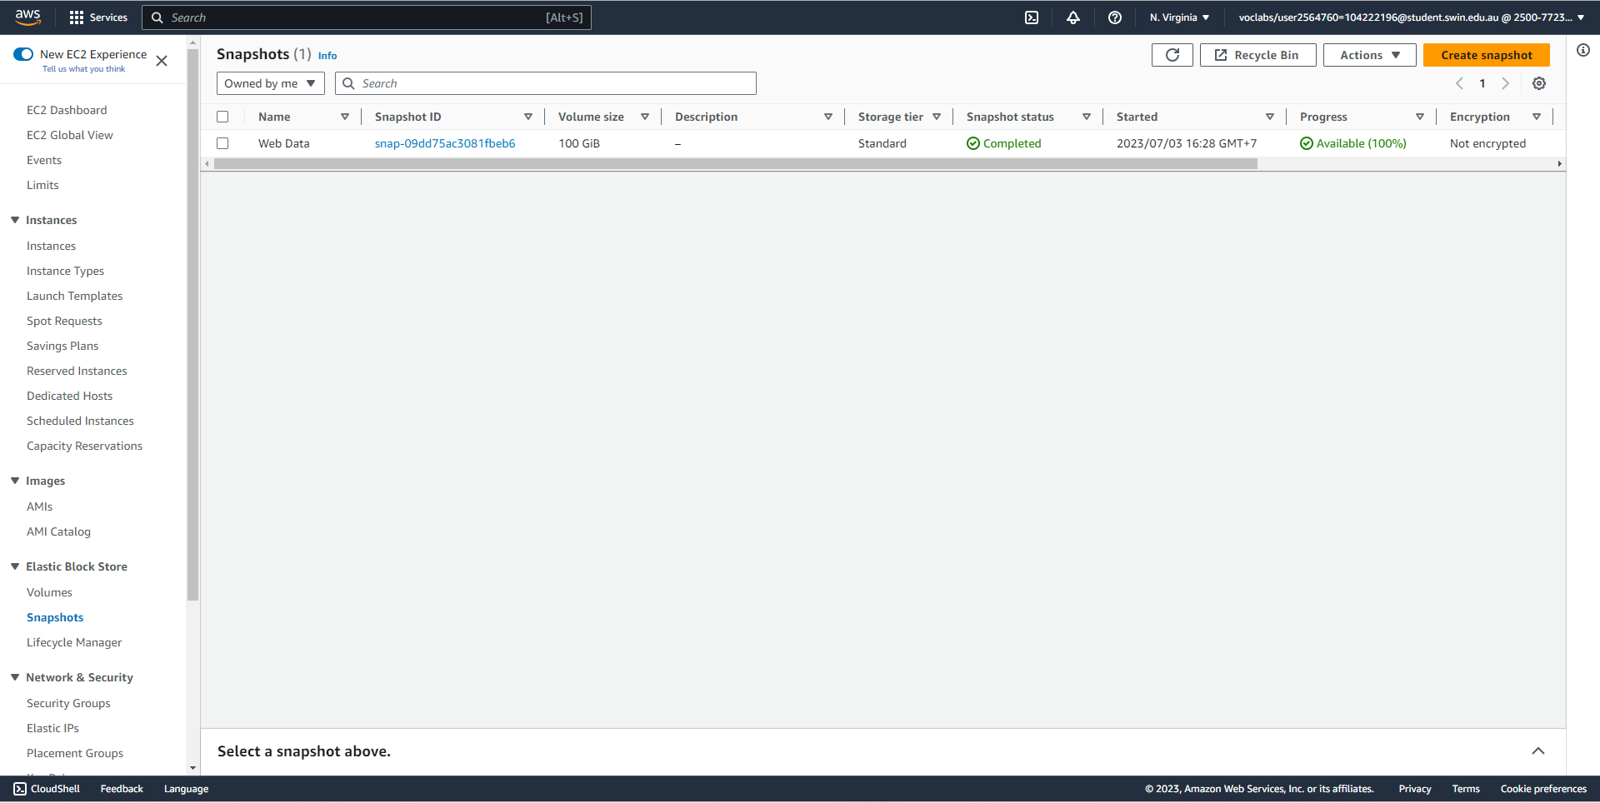



Steps 43-44: An EBS snapshot has been created after the deletion of the application stack, which is what the delete policy dictates.